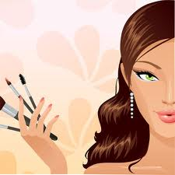

### IBT

Computer Science 101

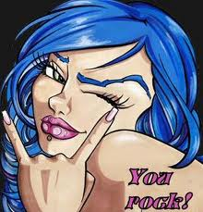n.

|  |  |
| --- | --- |
| Tom & Myspace | 2 |
| Graphic Design | 2 |
| Top 10 Apps | 2 |
| iPhone 5 | 2 |
| Computer Movies | 2 |

A Graphic designer can work on designing art work for a variety of things such as albums, t-shirts, performances, etc.

They plan concepts by studying information and materials. Graphic designers also illustrate concepts by designing rough layout of art and copy regarding arrangement, size, type size and style, and related aesthetic concepts. 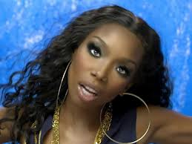 Real Photo 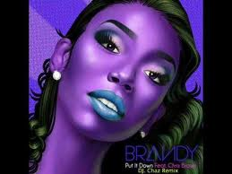

Graphic Design for Album Cover

## Graphic Designer

List other computer science jobs:

* Briefly highlight your point of interest here.
* Briefly highlight your point of interest here.
* Briefly highlight your point of interest here.
* Briefly highlight your point of interest here.

Inside this issue:

# Tom from My_Description: https://encrypted-tbn3.google.com/images?q=tbn:ANd9GcRbS0Ca8_r6xr1AaJm6pc7bsS8iEB2hD4oNjfvXxF0y-79w9WpR_Space

**Thomas "Tom" Anderson** (born 8 November 1970) is a US [internet entrepreneur](http://en.wikipedia.org/wiki/Internet_entrepreneur). He co-founded the [social networking](http://en.wikipedia.org/wiki/Social_networking_service) website [Myspace](http://en.wikipedia.org/wiki/Myspace) in 2003 with [Chris DeWolfe](http://en.wikipedia.org/wiki/Chris_DeWolfe), and was later president of Myspace and a strategic adviser for the company until he left in 2009. Because newly-created Myspace accounts initially included Tom as a default "friend", his face became known as the default picture of Myspace, and he is often referred to as "Tom from Myspace" or "Myspace Tom".

Myspace was a popular social network which allowed users to personalize their pages using template and formatting codes or developing their own codes.

The site took a major hit when Facebook started to become popular amongst mature users. Eventually the fan base transferred their accounts to another friendly place in cyberspace. Myspace is now focusing on Music and its television network.

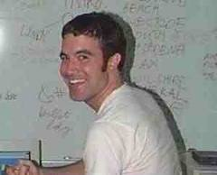

Newsletter /2015

Volume 1, Issue 1

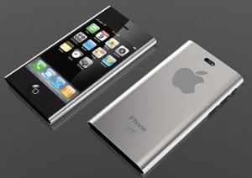While your main goal of distributing a newsletter might be to sell your product or service, the key to a successful newsletter is making it useful to your readers.

A great way to add useful content to this newsletter is to develop and write your own articles, or include a calendar of upcoming events or a special offer that promotes a new product.

You can also research articles or find “filler” articles by accessing the World Wide Web. You can write about a variety of topics but try to keep your articles short.

Much of the content you put in your newsletter can also be used for your Web site. Microsoft Word offers a simple way to convert your newsletter to a Web publication. So, when you’re finished writing your newsletter, convert it to a Web site and post it.

## Featured Computer Science Movie

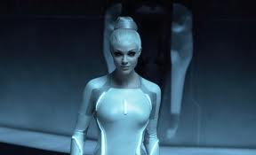TRON be used for your Web site. Microsoft Word offers a simple way to convert your Kevin Flynn ([Jeff Bridges](http://en.wikipedia.org/wiki/Jeff_Bridges)) is a [software engineer](http://en.wikipedia.org/wiki/Software_engineer) formerly employed by ENCOM. He had been fired by Ed Dillinger ([David Warner](http://en.wikipedia.org/wiki/David_Warner_%28actor%29)) who had stolen several [video games](http://en.wikipedia.org/wiki/Video_game) designed by Flynn to gain a series of promotions.

This is a great way to display technology in a movie, along with work ethics.

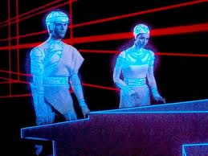

“To catch the reader's attention, place an interesting sentence or quote from the story here.”

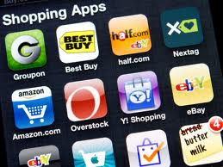There are a lot of apps for cosmetologist that assists with booking appointments, flipping through hairstyles, makeup and the latest products.

Stylistic is a popular app for fashion that allows users to keep up with all of their fashion accessories.

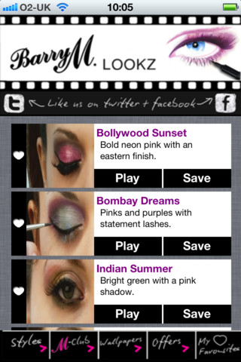

**1. Stylistic**

1. **Cutz**
2. **Moodz**
3. **Facialmania**
4. **Glamdolls**
5. **Styleseat**
6. **Lookbook**
7. **Stylemag**
8. **FashionSeat**
9. **Makeupbar**

## iPhone 5

## My Top Ten Favorite APPS